

Subject: Programming Fundamentals

Submitted to: Sir Usman Wajid

Submitted by: Muhammad Maaz

Registration no: 24P-3032

Semester: 1st

Department: Software Engineering

**FAST - National University of Computer and Emerging Sciences, Peshawar**

TASK#01:Steps of applying for University form.

1. 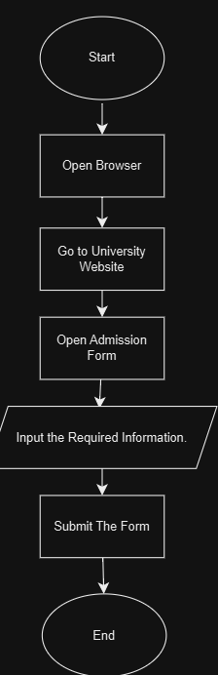Start.
2. Open Browser in PC.
3. Go to University website.
4. Open Admission Form.
5. Input The required information in the form.
6. Submit the Form
7. End.

TASK#02:Calculate the Average of Three numbers.

1. 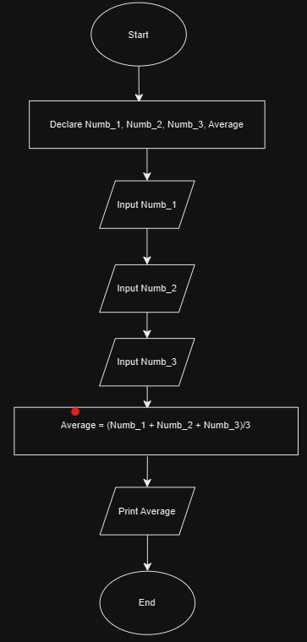Start.
2. Declare Numb_1, Numb_2, Numb_3 and Average.
3. Input Numb_1.
4. Input Numb_2.
5. Input Numb_3.
6. Average = (Numb_1 + Numb_2 + Numb_3)/2
7. Print Average
8. End.

TASK#03: Add four Number and then Take the Average.

1. 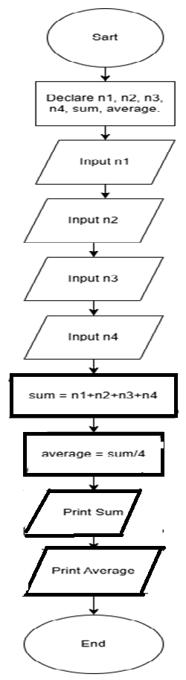Start
2. Declare n1, n2, n3, n4, sum, average
3. Input n1
4. Input n2
5. Input n3
6. Input n4
7. Sum=n1+n2+n3+n4
8. Average = Sum/4.
9. Print Sum
10. Print Average
11. End

TASK#4: Find the Area of Rectangle.

1. 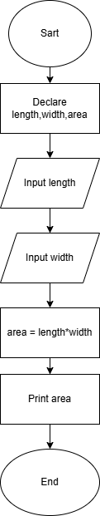Start
2. Declare length, width, area
3. Input length.
4. Input width
5. area = length*width
6. Print area

Print area

1. End

TASK#05: Write steps to find Percentage of Student Based on Math, Science, English, Urdu.

1. 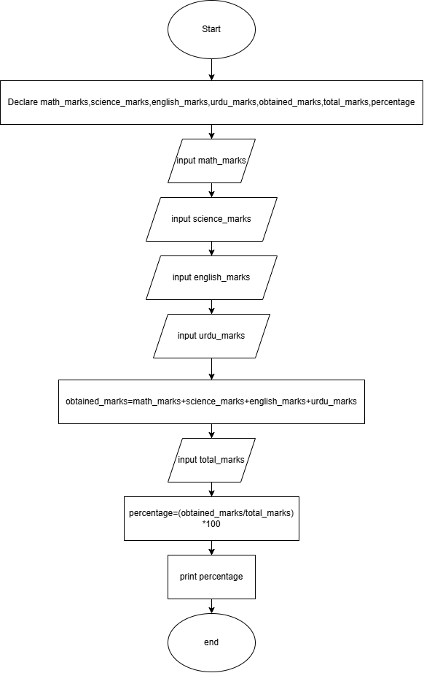Start
2. Declare math_marks, science_marks, english_marks, urdu_marks, marks_obtained, total_marks, percentage
3. Input math_marks
4. Input science_marks
5. Input english_marks
6. Input urdu_marks
7. obtained_marks= math_marks+ science_marks+ english_marks+ urdu_marks
8. Input total_marks.

Print Percentageepercentage

1. Percentage=

(obtained_marks/total_marks) *100

1. Print percentage
2. End

TASK#06: Calculate the Interest of a bank deposit (Formula: Amount*Years*Rate/100):

1. 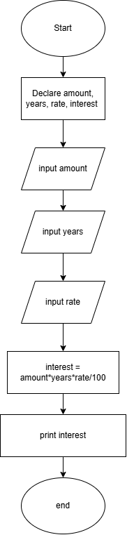Start
2. Declare amount, years, rate, interest.
3. Input amount.
4. Input years
5. Input rate (Not in percent).
6. Interest = (amount*years*rate/100)

Print Interest

1. Print interest
2. End

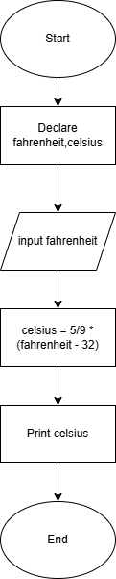TASK#07: Convert temperature from Fahrenheit to Celsius.

1. Start.
2. Declare Fahrenheit, Celsius.
3. Input Fahrenheit.
4. Celsius = 5/9 * (Fahrenheit – 32).

5.0 Print Celsius.

6.0 End

Print Celsius

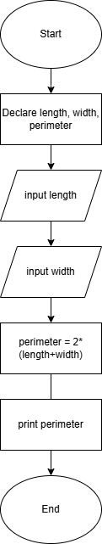TASK#08: Compute the perimeter.

1. Start.
2. Declare length, width, perimeter
3. Input length.
4. Input width.
5. perimeter = 2(length+width)
6. Print perimeter.
7. End.

Print perimeter

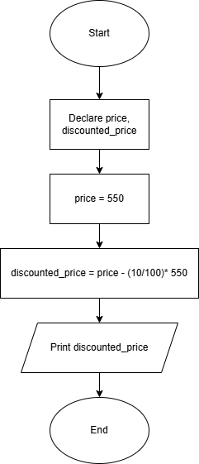TASK#09: A brand offers 10% discount on each shirt. Original price is 550. Find Discounted price of one shirt. Write the Pseudo code.

1. Start.
2. Declare price, discounted_price.
3. Price = 550.
4. discounted_price = 550 – (10/100) *550.
5. Print discounted_price.
6. End.

TASK#10: Write a program that will ask the user to input retail price and the sales tax rate and then display the total price and tax for the item.

1. 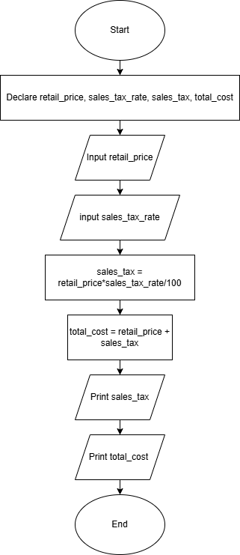Start.
2. Declare retail_price, sales_tax_rate, total_cost, sales_tax.
3. Input retail_price.
4. Input sales_tax_rate.
5. sales_tax= retail_price*sales_tax_rate/100
6. Total_cost=retail_price + sales_tax.
7. Print sales_tax.
8. Print total_cost.
9. End.

TASK#11: Write a program to find the total bill in Rupees of a person who buys 2 keyboards (100$ each) and three mouse (50$ each). Let 1$ = 215Rs.

1. 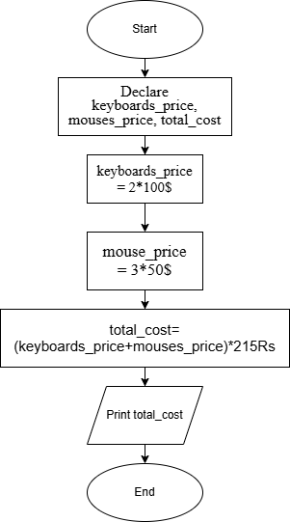Start
2. Declare keyboards_price, mouses_price, total_cost(Rs.).
3. keyboards_price = 2*100$
4. mouse_price = 3*50$

5.0 total_cost=

(keyboards_price+mouses_price) *215Rs

6.0Print total_price.

7.0 End.

TASK#12: Write a program that calculates the current balacnce in a current account. Take the input of starting balance, amount withdrawn and amount deposited. Then display the current balance. Write the Pseudo code.

1. 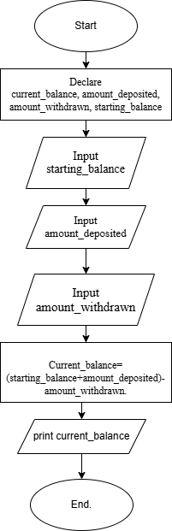Start
2. Declare current_balance, amount_deposited, amount_withdrawn, starting_balance.
3. Input starting_balance
4. Input amount_deposited
5. Input amount_withdrawn
6. Current_balance=(starting_balance+

amount_deposited)-amount_withdrawn.

1. Print current_balance.
2. End